1. Install GIT-SCM
   1. <https://git-scm.com/>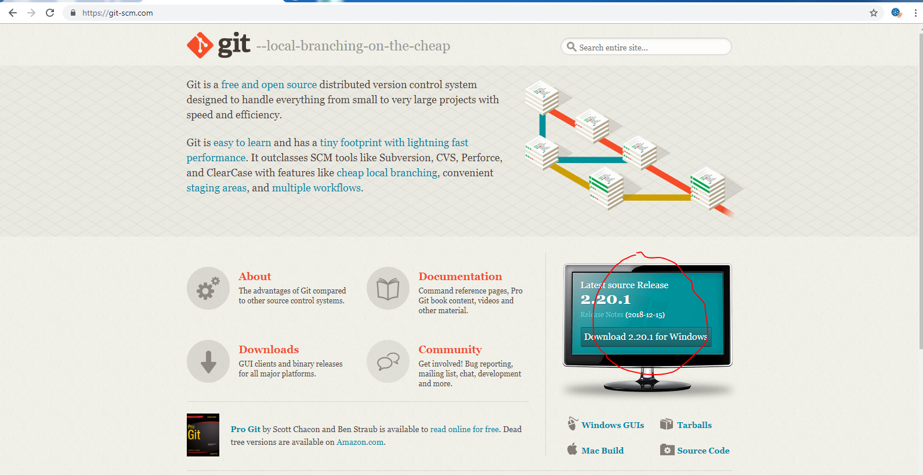
2. Create New Repository on GitHub
   1. New Repo

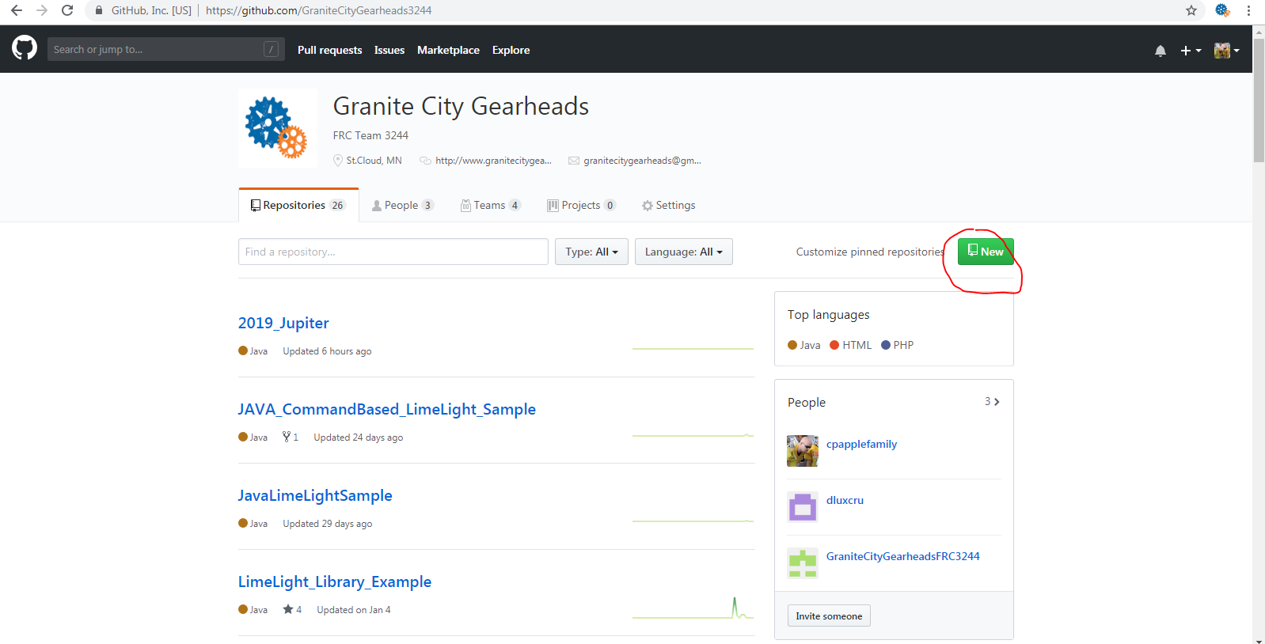

* 1. Do Not Initialize new Repository

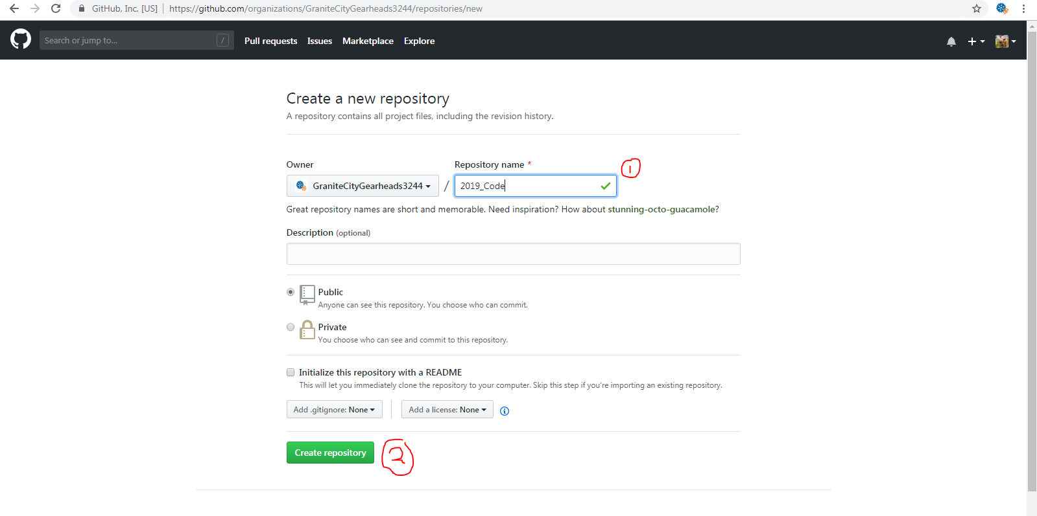

1. Open VSCode
   1. Open Project
   2. In the terminal run the following two Command (Only required once per Computer)
      1. git config --global user.name "FIRST_NAME LAST_NAME"
      2. git config --global user.email “[MY_NAME@example.com](mailto:MY_NAME@example.com)”
   3. Goto Git Tab and initialize local Git Repo

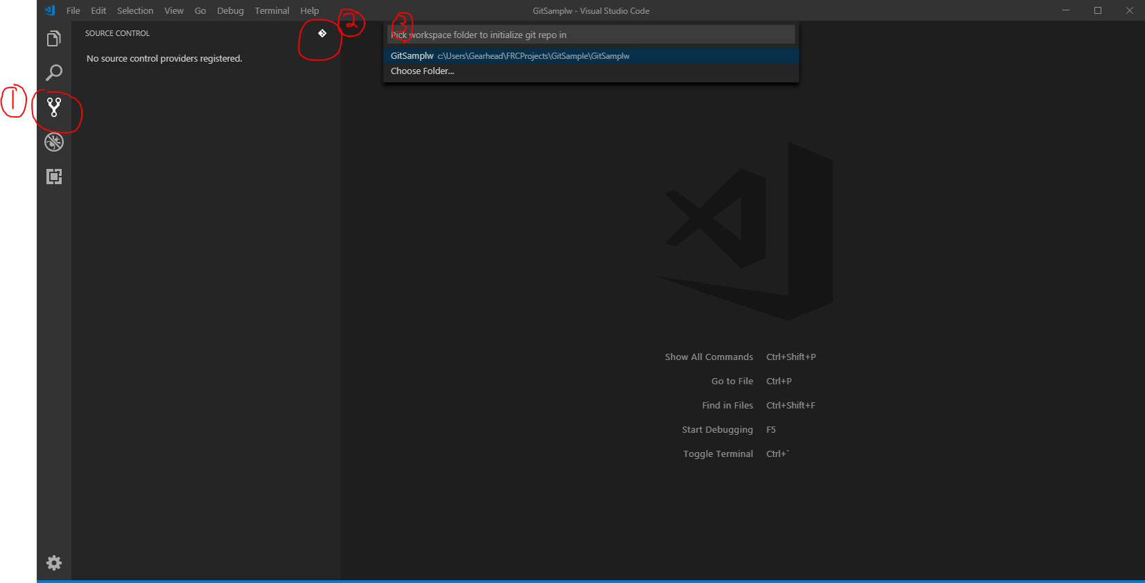

* 1. Create First Commit

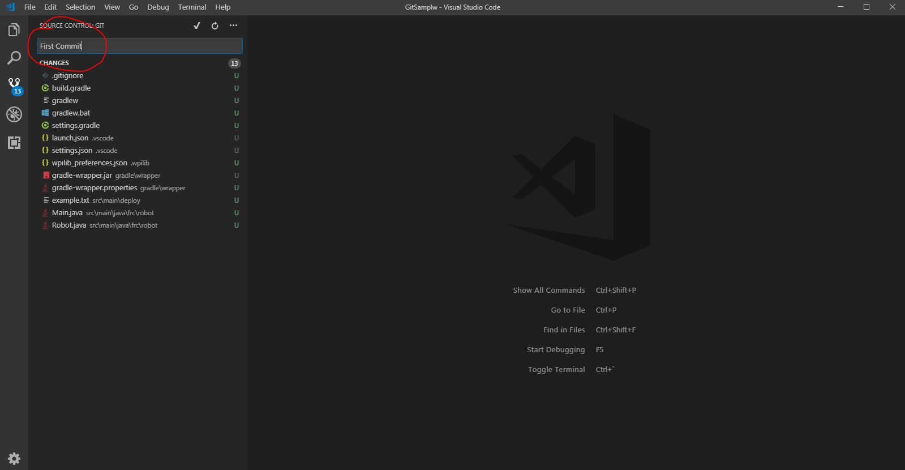

* 1. Press [Ctrl + Enter] and commit to local Project

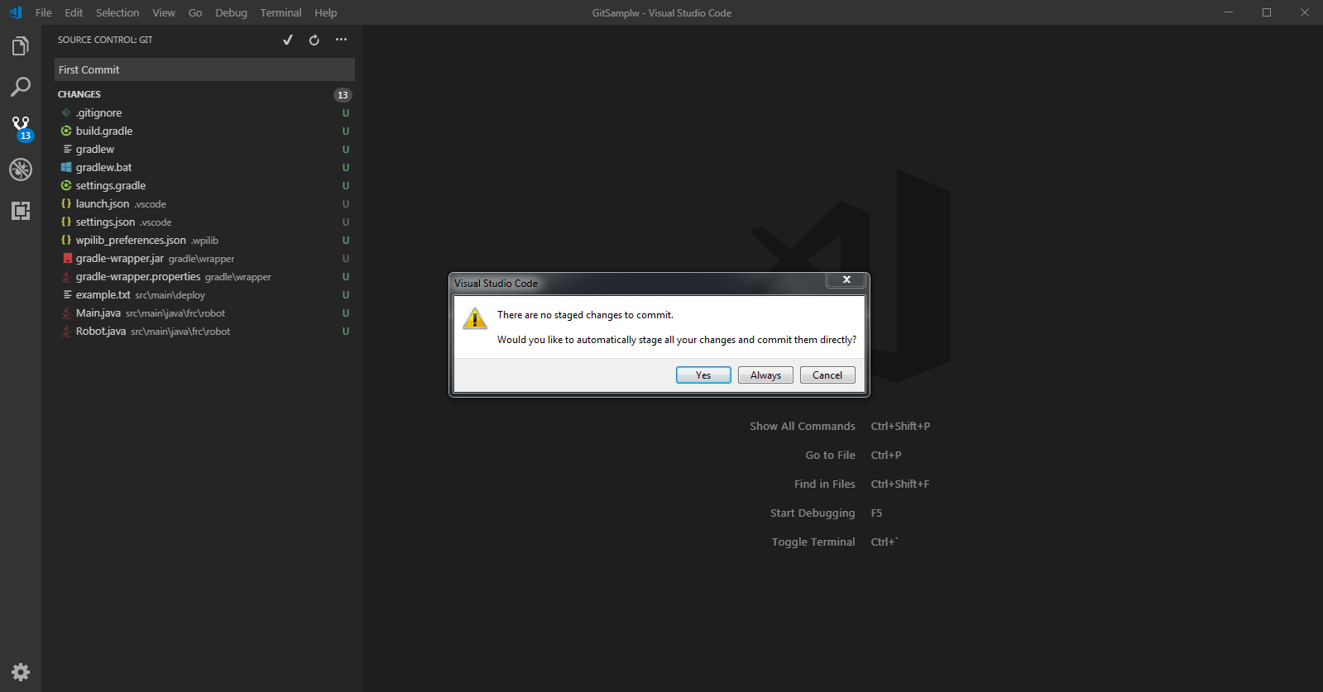

* 1. Copy Command Line code previous step created from GitHub

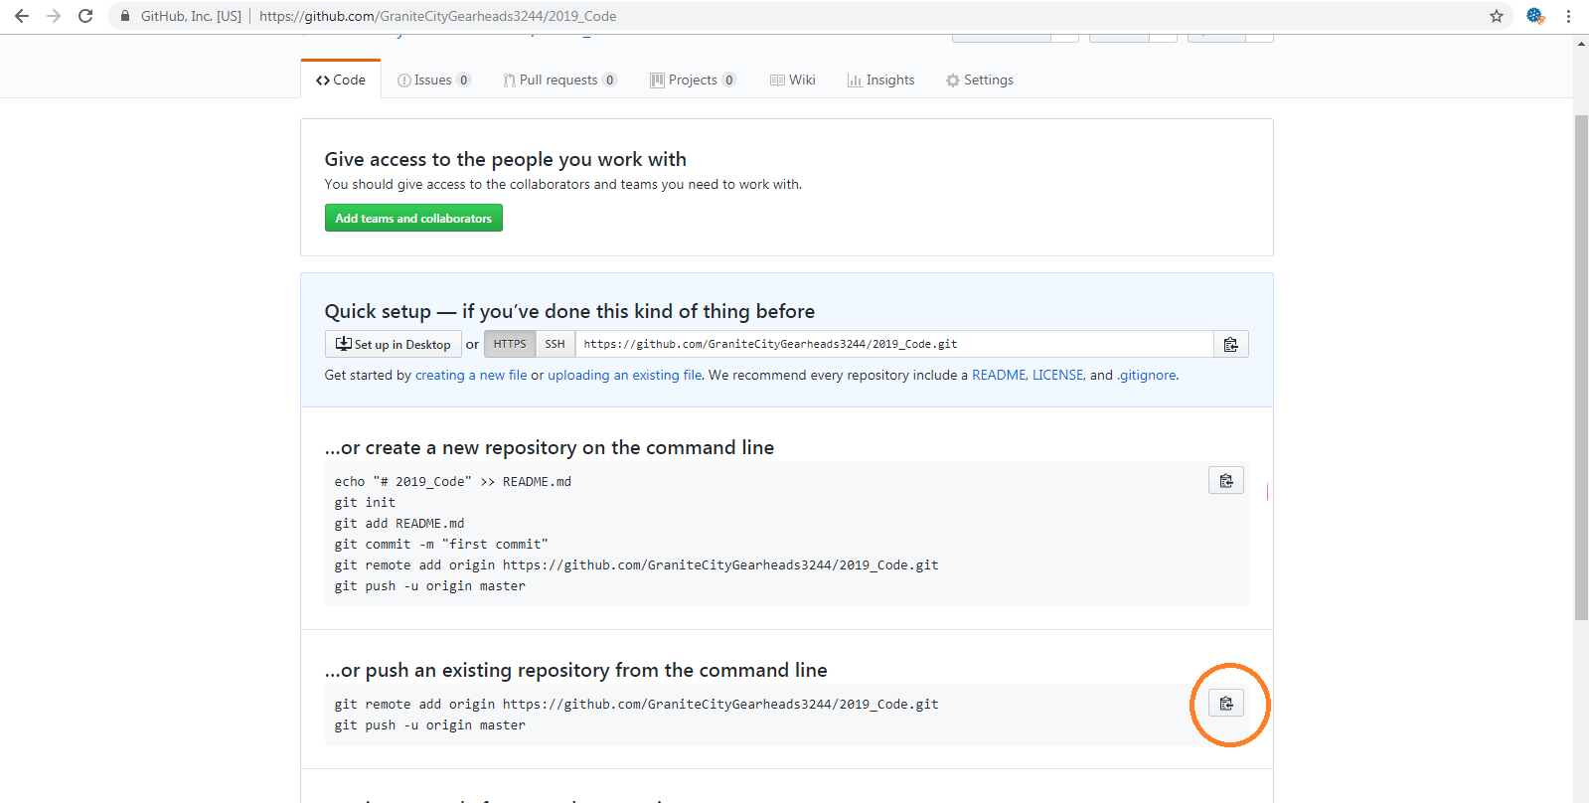

* 1. Open a terminal Prompt in VSCode Press [Ctrl + ~]
  2. Paste command into the Terminal and hit enter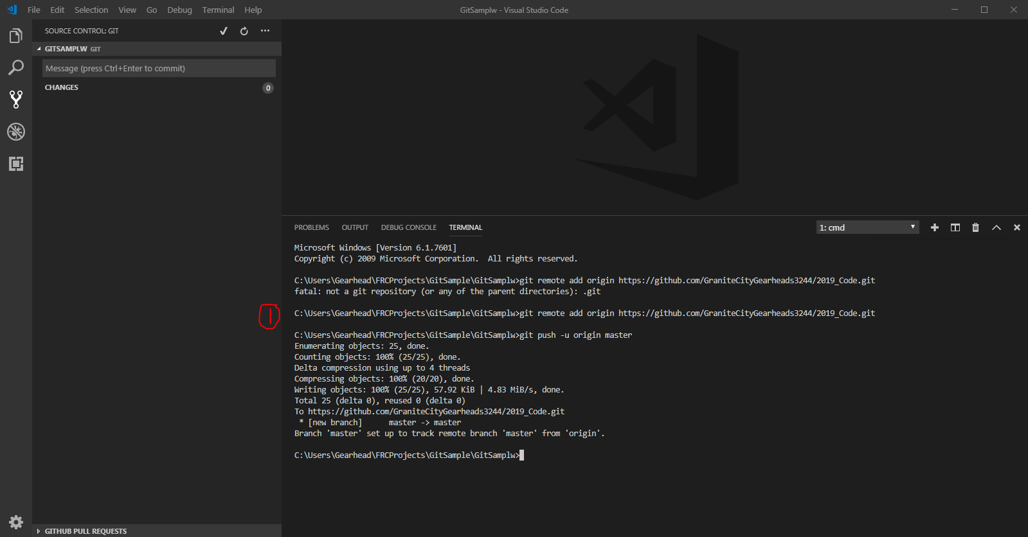
  3. Synchronize VSCode with Github (Bottom Left Corner)

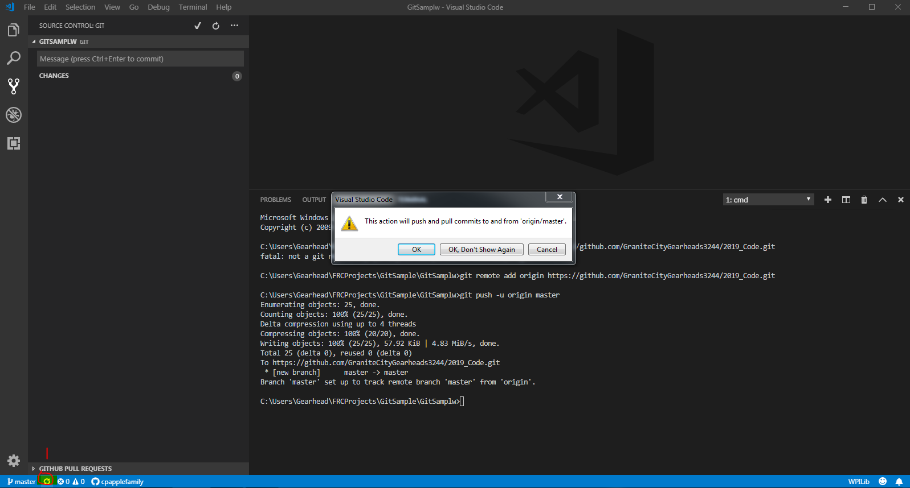

1. Committing Future changes to Git hub
   1. Add Commits to local Repo

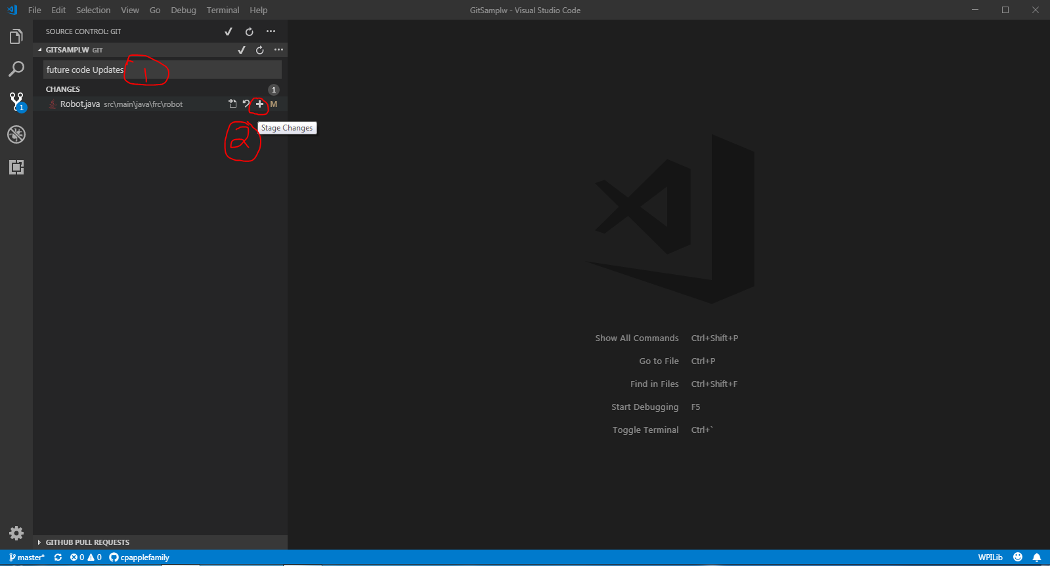

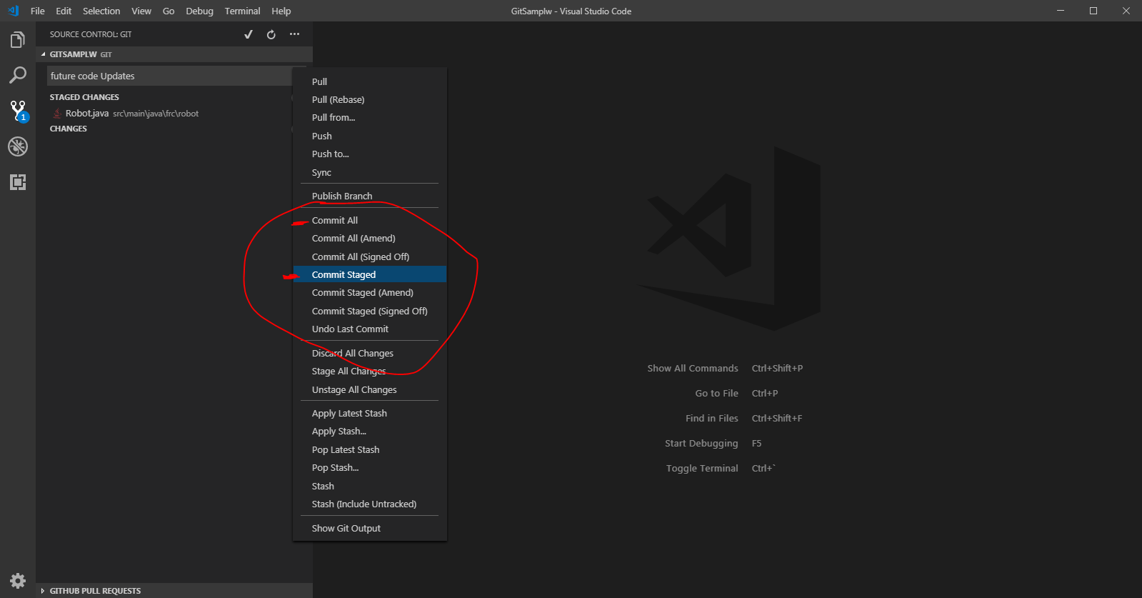

* 1. Push Commits to GitHub

